**DOCKER BUILD CREATION AND RUN FOR THE GDNT-R SDK**

**Details: (As part of gdntr-sdk-docker-env.tar.gz Deliverables)**

* Toolchain size is 102MB
* Sdk size is 110MB
* Dockerfile size is 4.0KB

Step 1: Extract below file in the Linux machine

**gdntr-sdk-docker-env.tar.gz**

extract command: **tar -xzvf gdntr-sdk-docker-env.tar.gz**

e.g: check below screenshot for your reference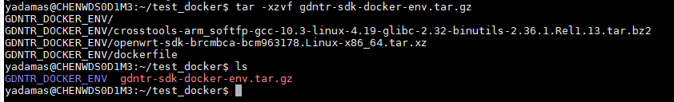

Step 2: Enter the GDNTR_DOCKER_ENV directory use below command

**cd** **GDNTR_DOCKER_ENV**

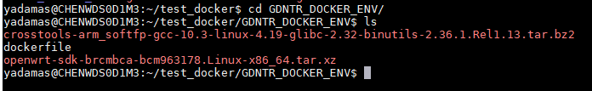

Step 3: Run below command to generate the build. it should take around 10 minutes

**docker build -t gdntr_sdk:1.0 .**



Step 4: check docker image created or not using below command

**docker images**

e.g: check below screenshot for your reference



Step 5: Run the below command to generate the docker container and enter the container

**docker run -ti gdntr_sdk:1.0 /bin/bash**

e.g: check below screenshot for your reference



Step 6: run below command to compile the SDK

**make -j1 V=sc**

e.g: check below screenshot for your reference



Linux Kernel Configuration window will be opened. just save and exit

**Note**: Default configuration only will be compiled

Step 7: Run below command to exit from the present container

Exit

e.g: check below screenshot for your reference



Step 8: To check the docker container details use below command

**docker ps -a**

e.g: check below screenshot for your reference



Step 9: To enter existing container using below command

**docker exec -it <container name> /bin/bash**

e.g: check below screenshot for your reference

